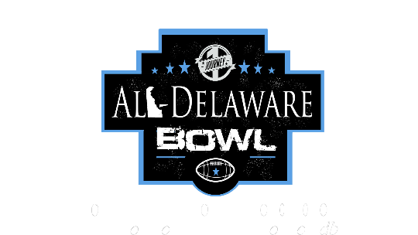
One Journey All-Delaware Bowl Sponsorship Proposal
Email: onejourney.nigel@outlook.com Phone: (302) 740-4942 Website: www.onejourneysports.com/ojadb
One Journey would like to thank you for your interest in sponsoring the 2nd Annual All-Delaware Bowl in which over 150 football players will be participating in front of over 500+ spectators in attendance from all the over. This one day event creates a unique partnering opportunity for organizations and businesses of the community to promote good health, team work, and competitive sporting fun while marketing their product/service!

There will be 4 All-Star games played featuring the top 3rd thru 8th grade football prospects from around the State of Delaware. The One Journey All-Delaware Bowl is intended to showcase Delaware's top youth football players all in one place.

The One Journey All-Delaware Bowl will take place on June 15th, 2019 at Appoquinimink H.S. 1080 Bunker Hill Rd, Middletown, DE 19709 from 11am-8:00pm.

There will be 4 games played:
- Class of 2028/2027 All-Star Game (Current 3rd & 4th Graders)
- Class of 2026/2025 All-Star Game (Current 5th & 6th Graders)
- Class of 2024 All-Star Game (Current 7th Graders)
- Class of 2023 All-Star Game (Current 8th Graders)

In addition to monetary sponsorship, donated items for prizes and giveaways will be greatly appreciated. The All-Delaware Bowl is seeking but not limited to the following items: gift certificates, coupons/discounts, tickets, gift baskets, and or anything else. Below, you will find information outlining our different sponsorship levels and their benefits. For sponsor/vendor registration, go to www.onejourneysports.com/ojdhc-sponsorship.

So please join us by sponsoring this classical event. We also have live vendor opportunities available as well. We will look forward to your reply by June 6th, 2019. Below, you will find more information outlining our different vendor & sponsorship levels as well as their benefits..

Levels of Sponsorship

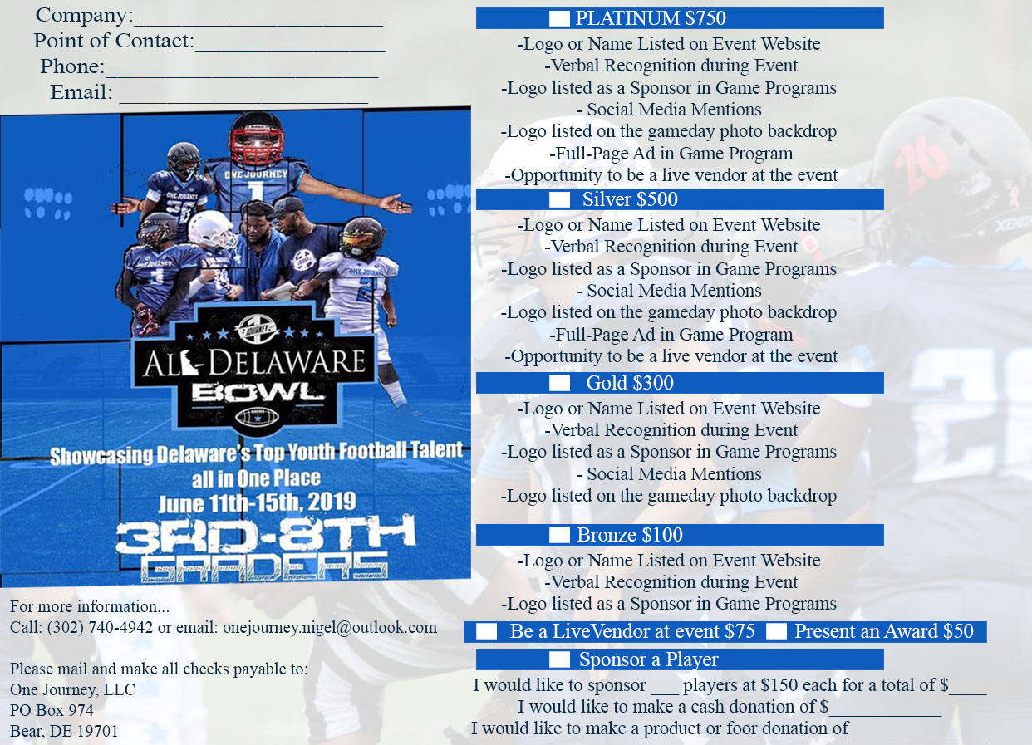

Vendor Opportunities

Showcase your product or service at the 2019 One Journey All-Delaware Bowl. Limited vendor registration space will be available at this event. All vendor tables are prepaid and include two guests. Vendors must read and sign the VENDOR INFORMATION AGREEMENT. Thank you for your interest.
​
Vendor Registration Fee - $75

- Vendor location - Near food concession stand or near both entrances or walkway near gate

- You must bring your own table and chairs (we will not supply table and chairs)

- Setup time Saturday (June 15th, 2019) 8:00am. Gates Open at 10:00am. The event will end around 8:00pm (this is an all day event).

- You must provide an insurance policy specifically stating that the Appoquinimink School District is additionally insured .

Agree to VENDOR INFORMATION AGREEMENT, complete agreement below to submit the vendor payment. For questions and/or concerns, contact Nigel Alexander via phone (302) 740-4942 or via email onejourney.nigel@outlook.com

Sponsorship Agreement

We, _________________________________________, agree to become a Sponsor for One Journey All-Delaware Bowl on June 15, 2019.

Platinum Package Sponsor $750 _____
Gold Package Sponsor $500 _____
Silver Package Sponsor $300_____
Bronze Package Sponsor $100_____
Vendor $100_____
Sponsor a MVP Trophy $50_____
Sponsor a Player’s Registration Fee $150_____ (this is for a less fortunate player and family that is interested in participating but doesn’t have the funds to do so. Your help would truly be appreciated)
In addition to monetary sponsorship, donated items for prizes and giveaways will be greatly appreciated. One Journey All-Delaware Bowl is seeking but not limited to the following items: Gift Certificates, Coupons or discounts, tickets, gift baskets, and or anything else.

Donation Amount: _____ or Donated Items/Service:_____________ _______________________________
□ Please check if you wish to remain anonymous.

Authorized Signature__________________________ Date__________

Printed Name________________________________ Title_________________________

Company/Organization Name________________________________

Work Phone Number______ _________________

Company Address (Street)______________________________________

Work Email_______________________________________

Company’s website____________________________________

Make mailed Checks payable to One Journey, LLC
[P.O Box 974, Bear, De 19701]
Email onejourney.nigel@outlook.com when you mail check off to confirm with us that you sent.
**Sponsorships received after June 6th, 2019 may not have benefits of event publications.
For online registration and payment visit: www.onejourneysports.com/ojdhc-sponsorship

In the event that One Journey shall be prevented from performing any of its obligations under the terms of this agreement by an act of God, by inclement weather (for example flash floods, excessive winds, lightning, fire, etc) or by the occurrence of any other event beyond its control, it shall be excused from any further performance of the obligations and undertakings set forth under the terms of this agreement. We regret that sponsorships are non-refundable. Sponsorships are limited and available on a first-come, first-serve basis.

